**Write a program to Print Fibonacci Series using recursion.**

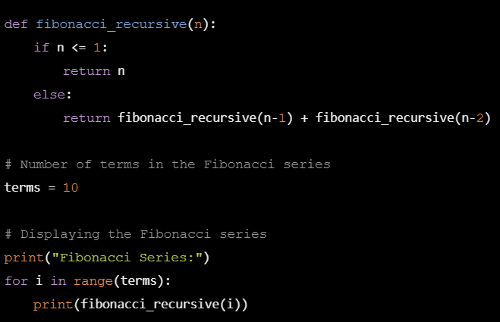

**Armstrong number:**

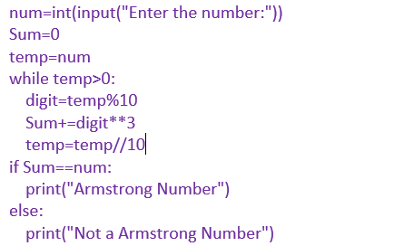

**Write a program to find the GCD of two numbers .**

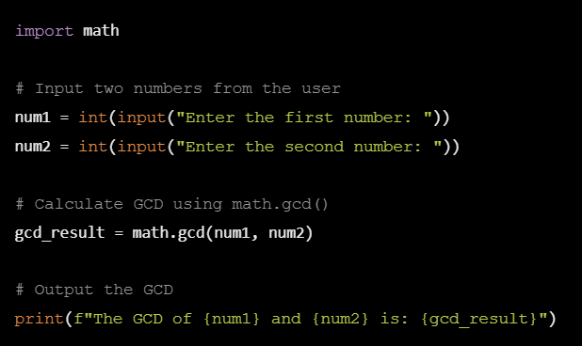

**Write a program to get the largest element of an array**

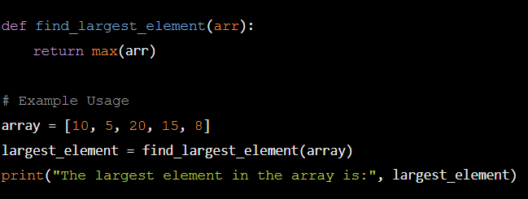

**Factorial number**

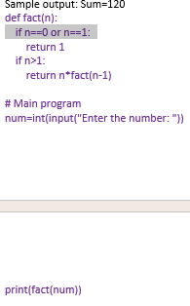

**Write a program to check a number is a prime number or not .**

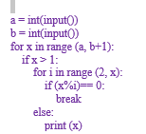

**Selection sort**

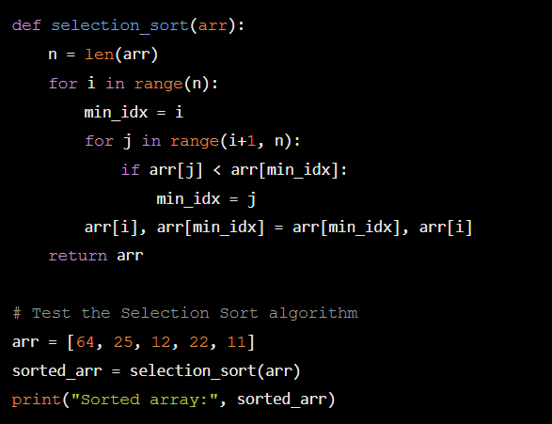

**Write a program to perform Bubble sort**

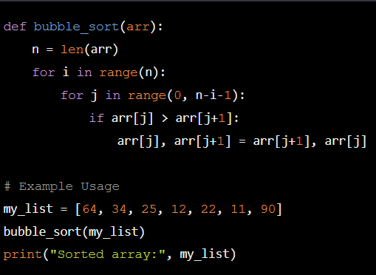

**Write a program for to multiply two Matrix**

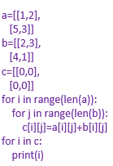

**Write a program for to check whether a given String is Palindrome or not** 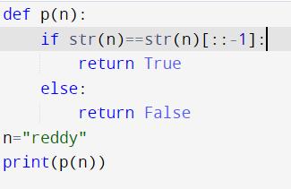

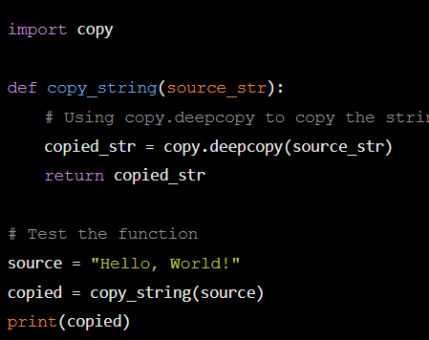

**Binary search:**

**import bisect**

**arr = [2, 4, 6, 8, 10, 12, 14, 16]**

**target = 6**

**index = bisect.bisect_left(arr, target)**

**if index < len(arr) and arr[index] == target:**

**print(f"Target found at index: {index}")**

**else:**

**print("Target not found")**

**reverse string:**

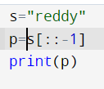

**Length of string:**

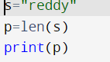

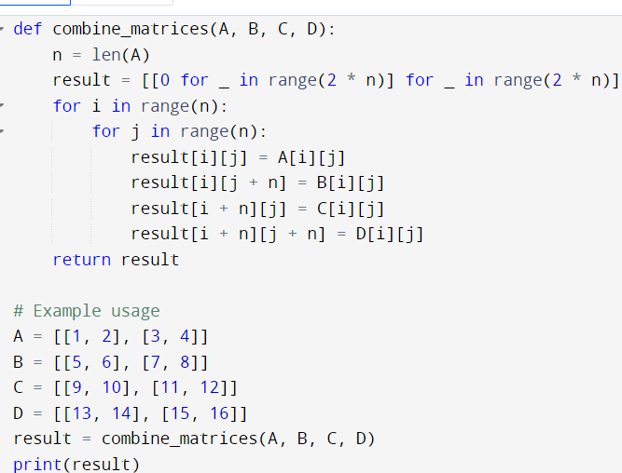

**Merge sort**

**import random**

**def generate_random_list(size):**

**return [random.randint(1, 100) for _ in range(size)]**

**arr = generate_random_list(10)**

**print("Original array:", arr)**

**sorted_arr = merge_sort(arr)**

**print("Sorted array:", sorted_arr)**

**Using Divide and Conquer strategy to find Max and Min value in the list**

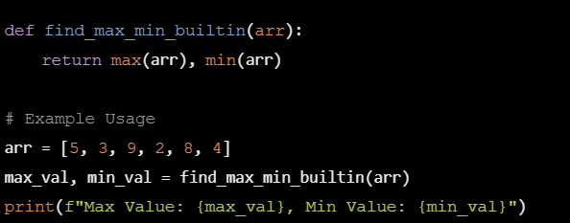

**. Write a program to generate all the prime numbers.**

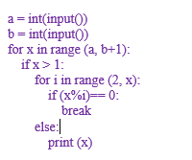

**to perform Knapsack problem using greedy techniques.**

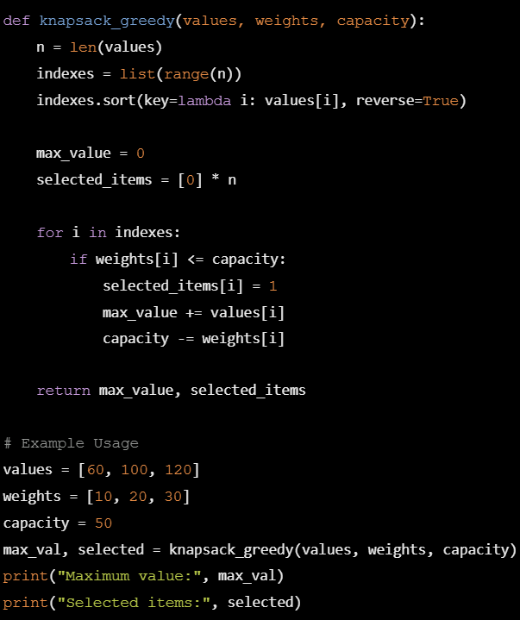

**Using Dynamic programming concept to find out Optimal binary search tree.**

**Using Dynamic programming techniques to find binomial coefficient of a given number**

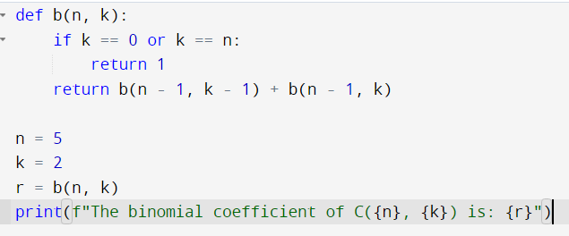

**Reverse number:**

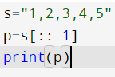

**. Write a program to find the perfect number.**

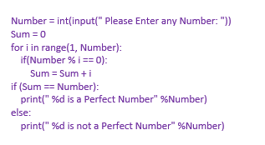

**Write a program to perform travelling salesman problem using dynamic programming**

**1**

**1 2**

**1 2 3**

**1 2 3 4**

**1 2 3 4 5**

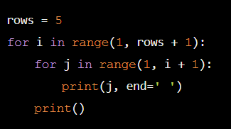

**Floyds triangle: algorthim**

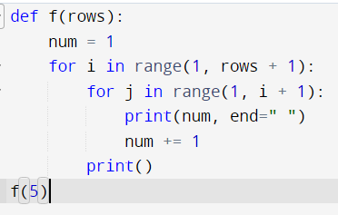

**Pascal triangle:**

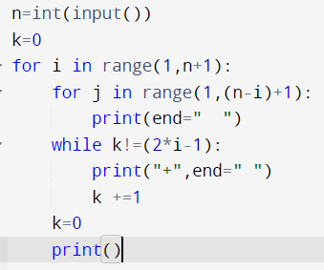

**Write a program to find the optimal cost by using appropriate algorithm**

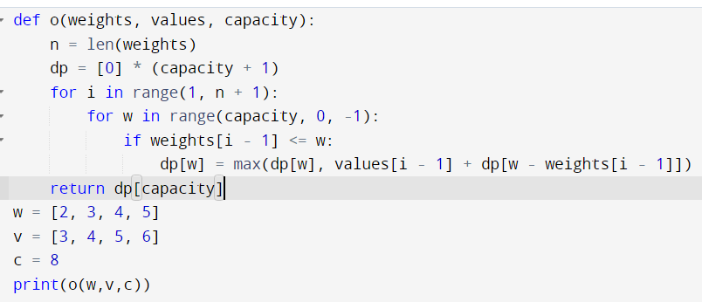

**Write a program to find the sum of digits.**

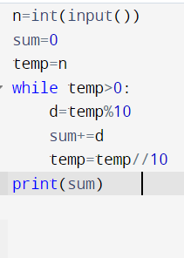

**Write a program for to perform liner search.**

def linear_search_string(words, target_word):

for i in range(len(words)):

if words[i] == target_word:

return i # Return the index if the target word is found

return -1 # Return -1 if the word is not found

word_list = ["apple", "banana", "cherry", "date"]

target_word = "banana"

result = linear_search_string(word_list, target_word)

if result != -1:

print(f"Word found at index: {result}")

else:

print("Word not found in the list")

**Write a program to generate the list of all factor for n value.**

def find_factors(n):

factors = []

for i in range(1, n + 1):

if n % i == 0:

factors.append(i)

return factors

n = 24

print(f"Factors of {n}: {find_factors(n)}")